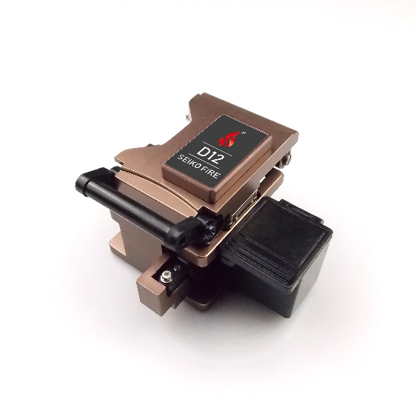
Fiber Cleaver D12
Specifications
Fiber diameter | 125µm
Outercoat diameter | 0.25mm-0.9mm
Fiber type | Single tube fiber and Ribbon fiber (exchangeable)
Cleaved length | 5-20mm
Cleaved angle | ≤0.5°
blade life | 48000
Mode | Semiautomatic
Fiber collector | Available
Dimension | 59mm(W)×55(D)mm×49mm(H)
Weight | 280g

